Central CDC SIC Report to Families
April 2023

2022-23 Achievements & Highlights
Central Child Development Center is a dual accredited early learning center through both Cognia Early Learning and the National Association for the Education of Young Children (naeyc).  Central CDC now has a Literacy Coach. In August CCDC welcomed Jane Hoesel to our staff. Mrs. Hoesel not only serves as our literacy coach but also works with several of our students as an academic interventionist.  This year students at Central CDC are participating in the Junior Master Gardener program offered through York County 4H. The 4-week program is a research & evidence-based curriculum project that combines academic achievement, gardening, nutrient-dense food experiences, physical activity, and school and family engagement.  Central CDC resumed conducting field studies this year. Field studies had previously been cancelled due to the COVID Pandemic. This year, students visited Christmasville and Cherry Place Farm. Additionally, our students will visit elementary school kindergarten classrooms, Miracle Park, or Glencairn Garden prior to the end of the school year.  This year Central CDC participated in the Duke Energy and Rock Hill Schools Education Foundation Science Night. Our students had the opportunity to participate in numerous science related experiments, demonstrations, and activities.  All students at Central CDC received books each month that correlated with our thematic units of instruction. The books were provided to strengthen our home to school learning connection. |  | Central CDC  SIC Members  Damon Ward  CCDC Director  Margaret Joiner  CCDC Teacher  Kelsey Moore  CCDC Teacher  Cissy Brown  Community Representative  Rob Joiner  Community Representative  Cam & Andrea Walters  Parent Representatives
School Vision: Ready for school! Ready for life!

Mission Statement: Our mission is to provide our students quality instruction with high levels of achievement in a safe and nurturing environment to ensure future success.

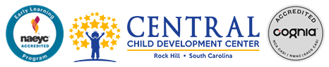
School Renewal Plan

Goals
School Climate Performance Goal  By the end of the 2023-24 school year, the percentage of teachers who respond "Agree" to "Students behave well in class" on the state Teacher Climate Survey data will increase from the 2017-18 baseline of 54.5% to 79.5% by 2023-24.  Teacher/Administrator Quality  By the end of the 2023-24 school year, 100% of required Central CDC staff will attain the mandatory SCDE R2S Endorsement. Baseline: As of March 2019, 27% of the required CCDC staff held the required R2S Endorsement for recertification. Annual updates: March 2020 = 55%; March 2021=68%. |  |  | Student Achievement Performance Goal  By the end of the 2023-24 school year, Central CDC will increase the percentage of ESE children age 3-5 attending regular programs to meet or exceed the 2016-17 SCDE State average of 56.3% (RHSD baseline from the 2017-18 SCDE audit review was 40.0%).  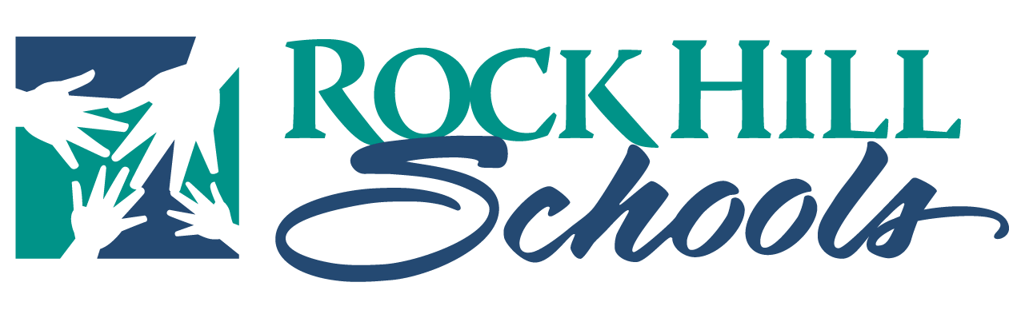
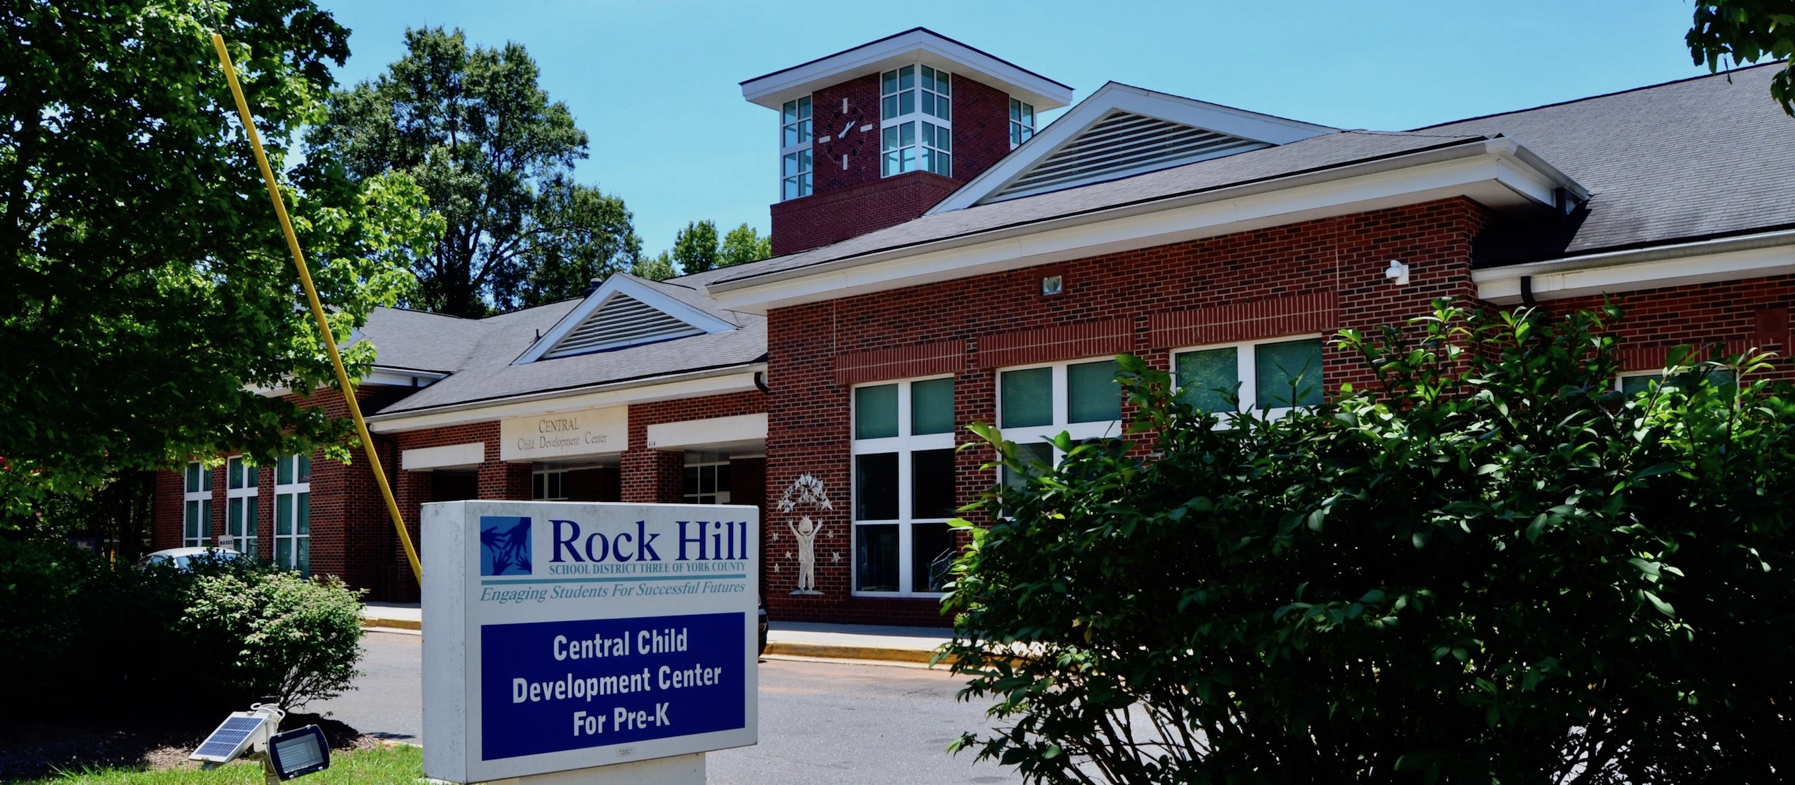
 | “This Report is issued by the Central Child Development Center’s School Improvement Council in accordance with South Carolina law to share information on the school's progress in meeting various goals and objectives, the work of the SIC, and other accomplishments during the school year.”

